HealthFirst Care Risk Matrix and Mitigation Plan
Capstone Project M05L02
Adwoa Boama Acheampong | IBM Business Analyst learning project

Priority and planning basis
R01 and R02 have the maximum initial score of 9. R04, R06 and R07 score 6 and are also High on the 3 × 3 planning matrix. These five high-priority risks require prevention, trigger, owner and contingency; the remaining five are monitored with the same fields. No residual reduction is claimed until controls are tested and owners rescore each risk.

Updated 3 × 3 priority matrix
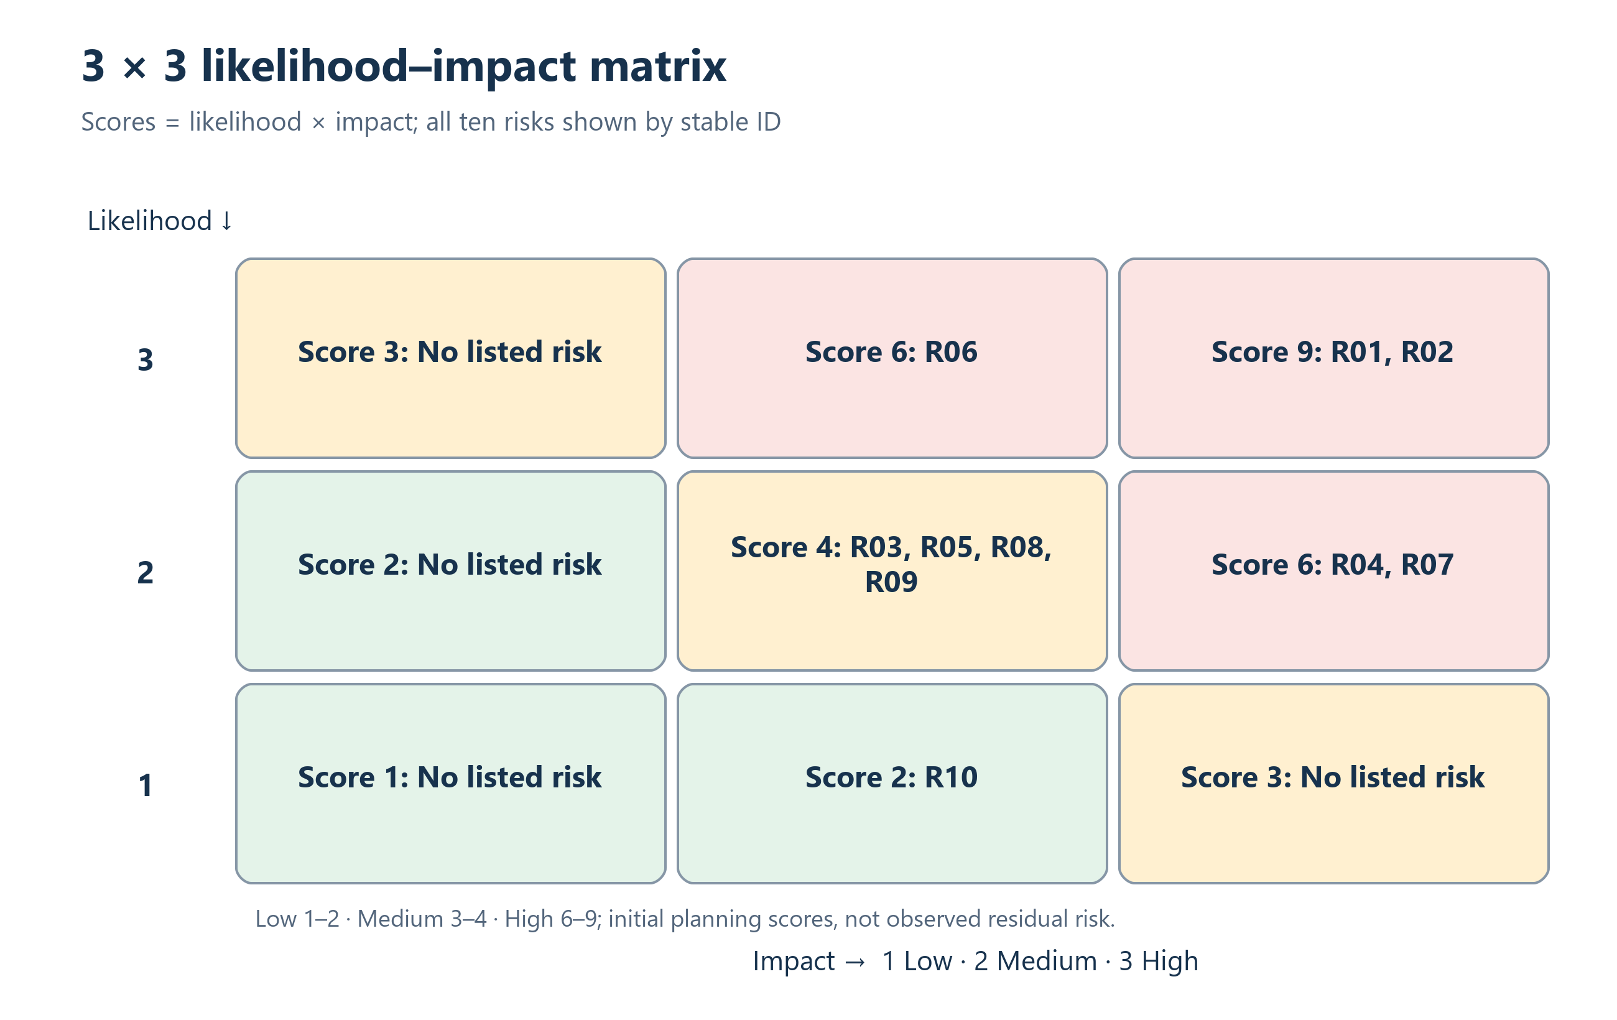
Initial positions are shared with the risk register. After evidence-based mitigation, owners update likelihood and impact in the workbook; the matrix recalculates from those inputs.
ID | Preventive action | Owner | Trigger | Contingency | Residual target | Review
R01 | Conflict rules, scenario UAT and daily exception review | Operations manager | Double booking or override trend | Pause affected scheduling path; use controlled manual calendar and reconcile later. | Unscored; review after test | Daily during pilot
R02 | Field mapping, reconciliation, retry queue, monitoring and rollback | IT manager | Stale sync or reconciliation variance | Disable failing interface; use validated batch extract and preserve exception log. | Unscored; review after test | Daily during pilot
R03 | Department thresholds, protected capacity and escalation | Clinical operations | Wait or utilisation threshold breach | Rebalance slots/resources or invoke approved surge, transfer or reschedule rules. | Unscored; review after test | At each stage gate
R04 | Least privilege, MFA, audit logging, encryption and incident exercises | Security lead | Unauthorized access or delivery exposure | Contain access, preserve evidence and invoke the approved privacy incident process. | Unscored; review after test | Daily during pilot
R05 | Co-design, role training, floor support and usage review | Change lead | Bypass or duplicate-entry trend | Remove unsafe parallel process, deploy champions and target retraining. | Unscored; review after test | At each stage gate
R06 | Validation rules, exception queue, ownership and quality scorecard | Data owner | Missing or duplicate keys rise | Qualify affected KPI, quarantine suspect rows and correct the source before decision use. | Unscored; review after test | Daily during pilot
R07 | Downtime procedure, monitoring and reconciliation drills | IT incident lead | Connectivity or service outage | Use the approved downtime list and reconcile every record after restoration. | Unscored; review after test | Daily during pilot
R08 | Accessibility review, assisted booking and usability testing | Patient experience lead | Abandonment or support complaints | Switch to assisted booking or check-in and correct inaccessible content. | Unscored; review after test | At each stage gate
R09 | Metric dictionary, denominator review and formal baseline approval | Project sponsor | Conflicting dashboard interpretations | Suspend the disputed KPI from decision use until definition and baseline are approved. | Unscored; review after test | At each stage gate
R10 | Scope baseline, change assessment and sponsor decision | Project manager | Unplanned deliverable or dependency | Stop unapproved work and route the change through sponsor review. | Unscored; review after test | At each stage gate

Escalation and continuity
Event | Immediate action | Continuity method | Decision owner
Scheduling or HIS outage | Declare incident and preserve current queue | Controlled downtime list with reconciliation | IT incident lead
Incorrect or missing feed | Quarantine affected dashboard data | Show freshness warning and use validated prior extract | Data owner
Notification failure or exposure | Stop repeated sends and assess recipients | Phone high-risk changes using minimum necessary data | Operations and security
Capacity threshold breach | Escalate and reassess appointments | Approved overflow, transfer or reschedule rule | Clinical lead
Critical security event | Revoke access, contain and preserve evidence | Approved minimum-data manual process | Security lead

Acceptance evidence
- Control owner is named and accepts responsibility.
- Trigger can be observed from an agreed source.
- Preventive control passes its planned test.
- Contingency is exercised or walkthrough evidence is retained.
- Residual score and any remaining limitation are reviewed by the sponsor.

Conclusion
The mitigation plan is complete as a planning artifact. It does not claim that controls have been implemented, tested or accepted. Those statuses remain open in the RTM and risk register until evidence is added.

