HealthFirst Care Risk Register and SWOT Analysis
Capstone Project M05L01
Adwoa Boama Acheampong | IBM Business Analyst learning project

Method
Risks are written as cause, event and consequence. Likelihood and impact each use the course's three-point Low (1), Medium (2) and High (3) scale. Multiplication gives Low 1–2, Medium 3–4 and High 6–9. These initial scores are analyst planning judgments for owner validation, not measured probabilities or approved residual risks.
ID | Risk | Category | L | I | Score | Owner | Control | Trigger
R01 | Configuration does not prevent scheduling conflicts, so double bookings continue and patient delay persists. | Operational | 3 | 3 | 9 | Operations manager | Conflict rules, scenario UAT and daily exception review | Double booking or override trend
R02 | Legacy interfaces fail or lag, creating incomplete records and unreliable operational decisions. | Technical/data | 3 | 3 | 9 | IT manager | Field mapping, reconciliation, retry queue, monitoring and rollback | Stale sync or reconciliation variance
R03 | Demand exceeds staffing, room or equipment capacity, shifting rather than removing bottlenecks. | Capacity | 2 | 2 | 4 | Clinical operations | Department thresholds, protected capacity and escalation | Wait or utilisation threshold breach
R04 | Weak access or notification controls expose patient information and create privacy harm. | Security | 2 | 3 | 6 | Security lead | Least privilege, MFA, audit logging, encryption and incident exercises | Unauthorized access or delivery exposure
R05 | Staff bypass the new workflow, creating duplicate entry and inconsistent records. | Adoption | 2 | 2 | 4 | Change lead | Co-design, role training, floor support and usage review | Bypass or duplicate-entry trend
R06 | Missing, duplicated or mismatched source data distorts dashboards and priorities. | Data quality | 3 | 2 | 6 | Data owner | Validation rules, exception queue, ownership and quality scorecard | Missing or duplicate keys rise
R07 | Network downtime interrupts booking, check-in or notifications and delays service. | Continuity | 2 | 3 | 6 | IT incident lead | Downtime procedure, monitoring and reconciliation drills | Connectivity or service outage
R08 | Patient self-service design excludes users who need assisted channels. | Stakeholder/access | 2 | 2 | 4 | Patient experience lead | Accessibility review, assisted booking and usability testing | Abandonment or support complaints
R09 | Unapproved or poorly defined KPI thresholds create misleading performance judgments. | Governance | 2 | 2 | 4 | Project sponsor | Metric dictionary, denominator review and formal baseline approval | Conflicting dashboard interpretations
R10 | Scope expands into clinical decision-making or full platform replacement, delaying the pilot. | Scope | 1 | 2 | 2 | Project manager | Scope baseline, change assessment and sponsor decision | Unplanned deliverable or dependency

Likelihood and impact matrix
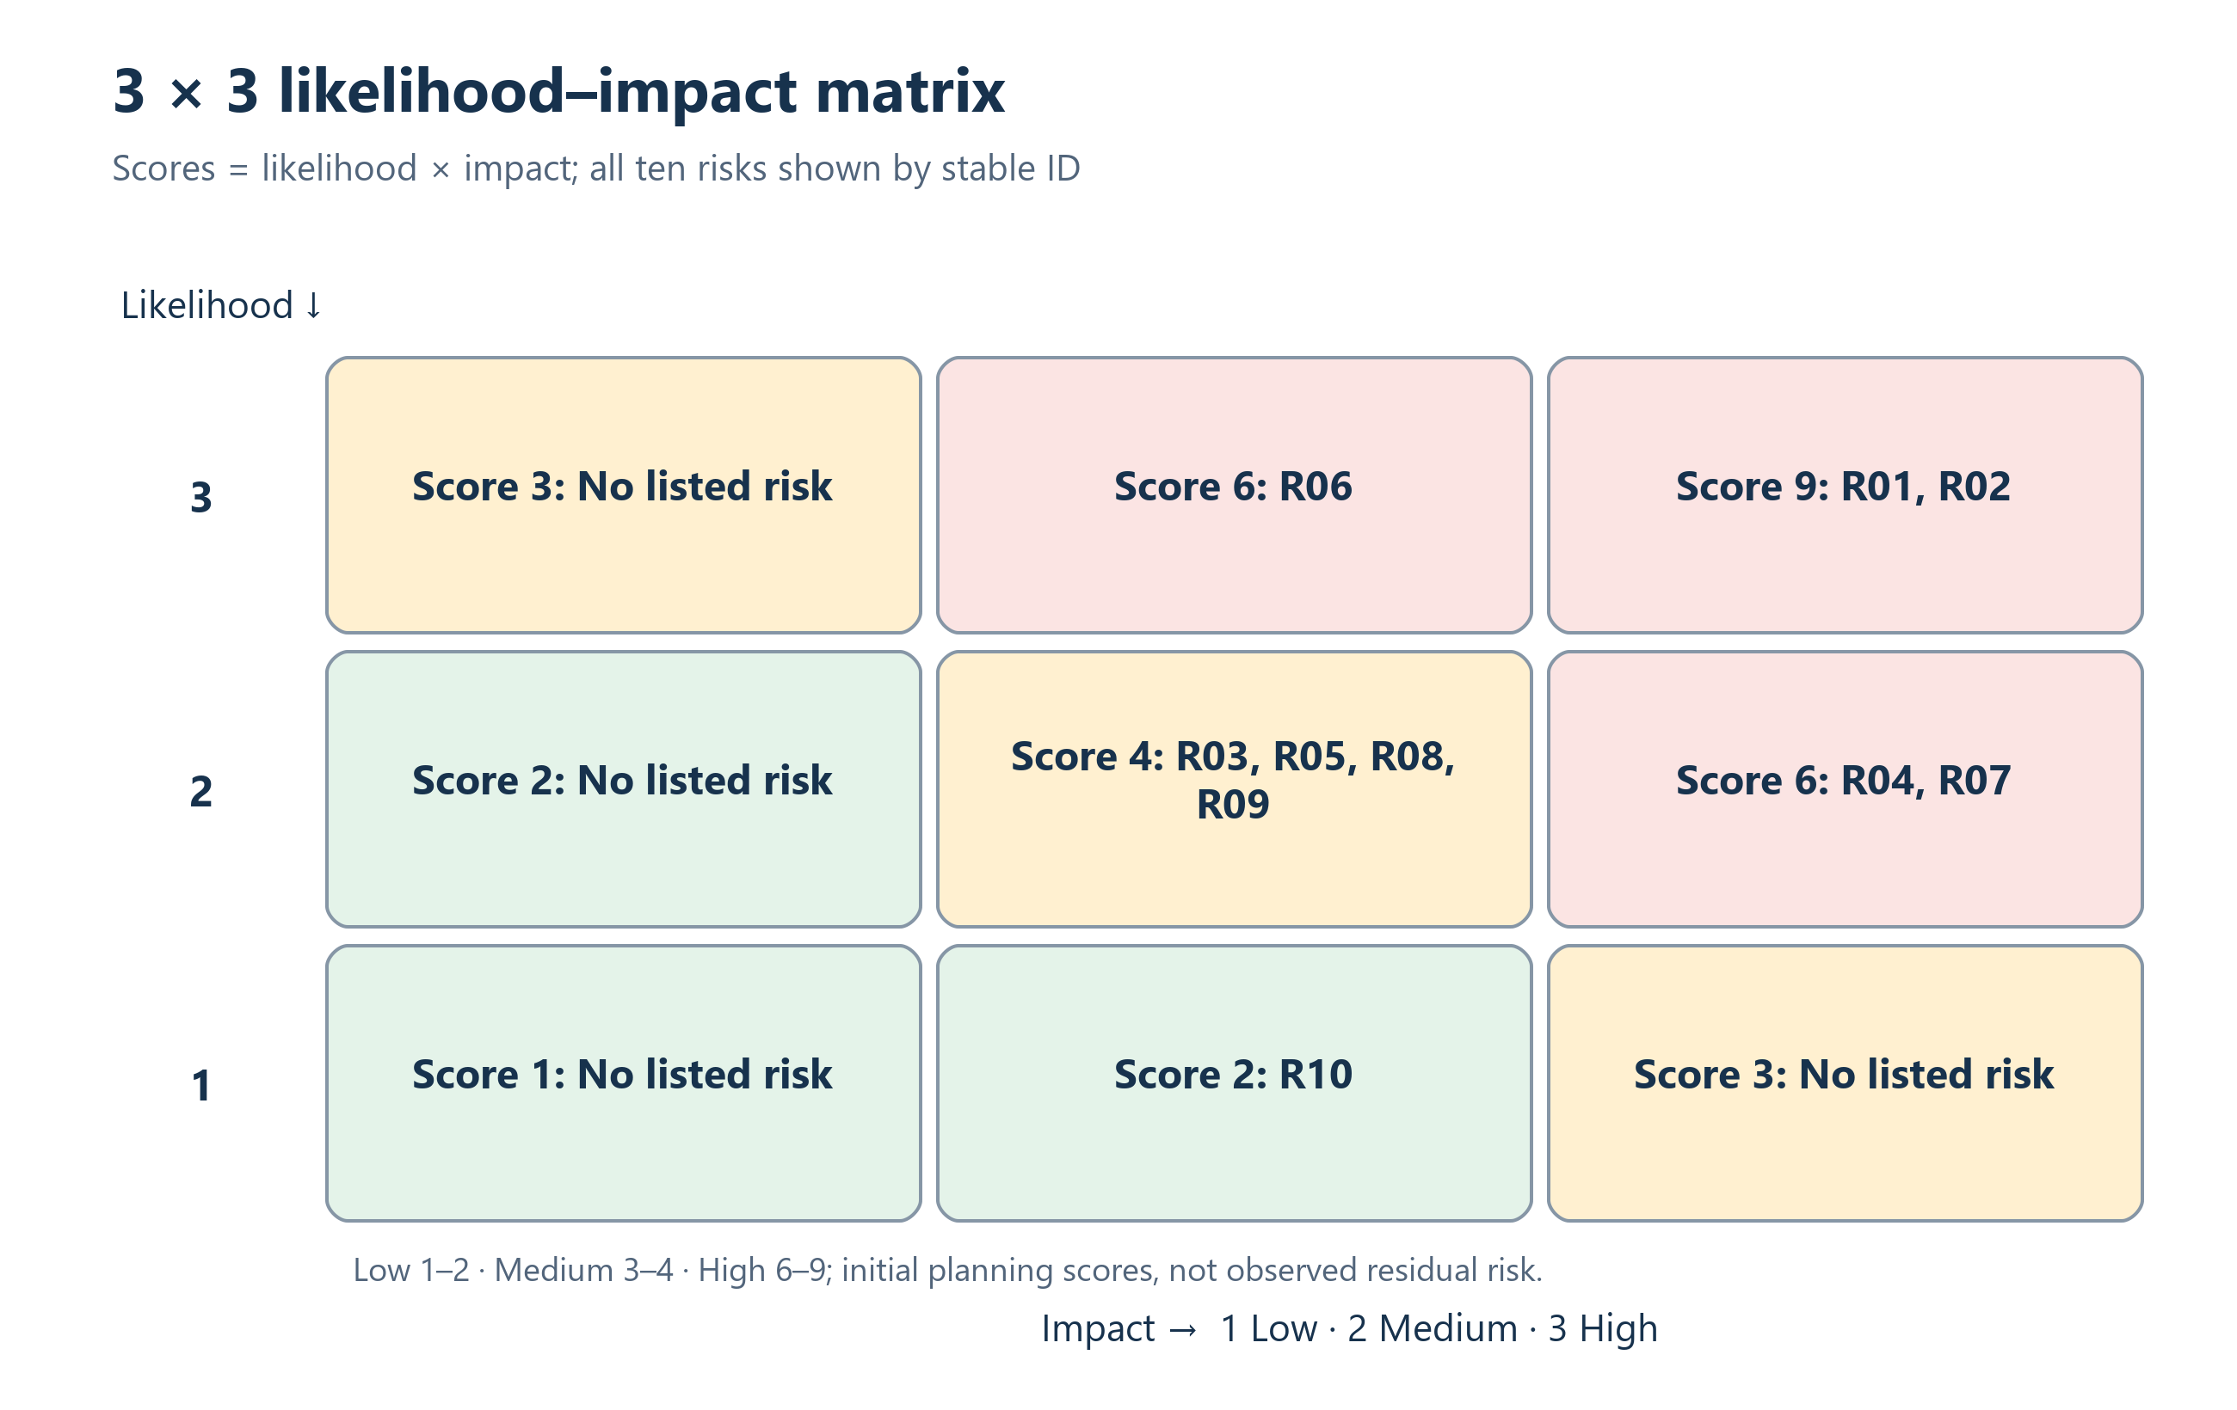
Risk placement is linked to the register scores and should be reassessed after control testing.

SWOT analysis
Strengths | Weaknesses | Opportunities | Threats
Operational datasets and concrete profiles exist | Disconnected systems and missing or duplicated records | Shared capacity visibility and conflict controls | Security or notification exposure
Named workflow pain points support traceability | Low completion and material no-show signals | Timely notices and assisted channels | Poor adoption creates parallel work
A phased pilot can limit exposure | Only department links all datasets | Governed analytics can support local action | Peak demand may shift bottlenecks
Editable project artifacts support review | Targets and approvals are not yet baselined | Exception data can guide iteration | Scope expansion can delay the pilot

How SWOT changes priorities
- Pilot where department signals justify it; show data-quality exceptions before leadership relies on the dashboard.
- Pair automation with assisted access and downtime procedures; make security, continuity, reconciliation and conflict detection release gates.
- Owners review triggers at each gate and after incidents; only the sponsor accepts residual risk.

