HealthFirst Care Detailed Process Maps and Swimlane Diagrams
Capstone Project M03L02
Adwoa Boama Acheampong | IBM Business Analyst learning project

Purpose and notation
The diagrams assign work to visible roles and systems. Rounded tasks represent activities. Sequence runs left to right within each lane. Cross-lane alignment represents a handoff. The diagrams are BPMN-informed planning models, not executable BPMN files and not validated as conformant process-engine definitions.

Exception rework and escalation paths
Workflow | Trigger | Immediate route | Escalation or continuity
Appointment | Preferred slot unavailable or conflict detected | Offer alternatives or waitlist | Operations reviews persistent conflict trend
Check in | Identity, appointment or required detail cannot be validated | Front desk exception queue | Clinical lead decides urgent-care route when delay affects safety
Resource allocation | Required resource unavailable | Select approved alternative or delay with reason | Clinical operations activates surge or transfer rule
Discharge | Critical workstream incomplete or patient does not understand plan | Keep discharge open and repeat or resolve task | Clinical lead decides safe continuation or alternative plan
Role assignments and exception rules require stakeholder validation before operational use. No interview, sign-off, deployment or measured cycle-time improvement is claimed.

Appointment scheduling and confirmation
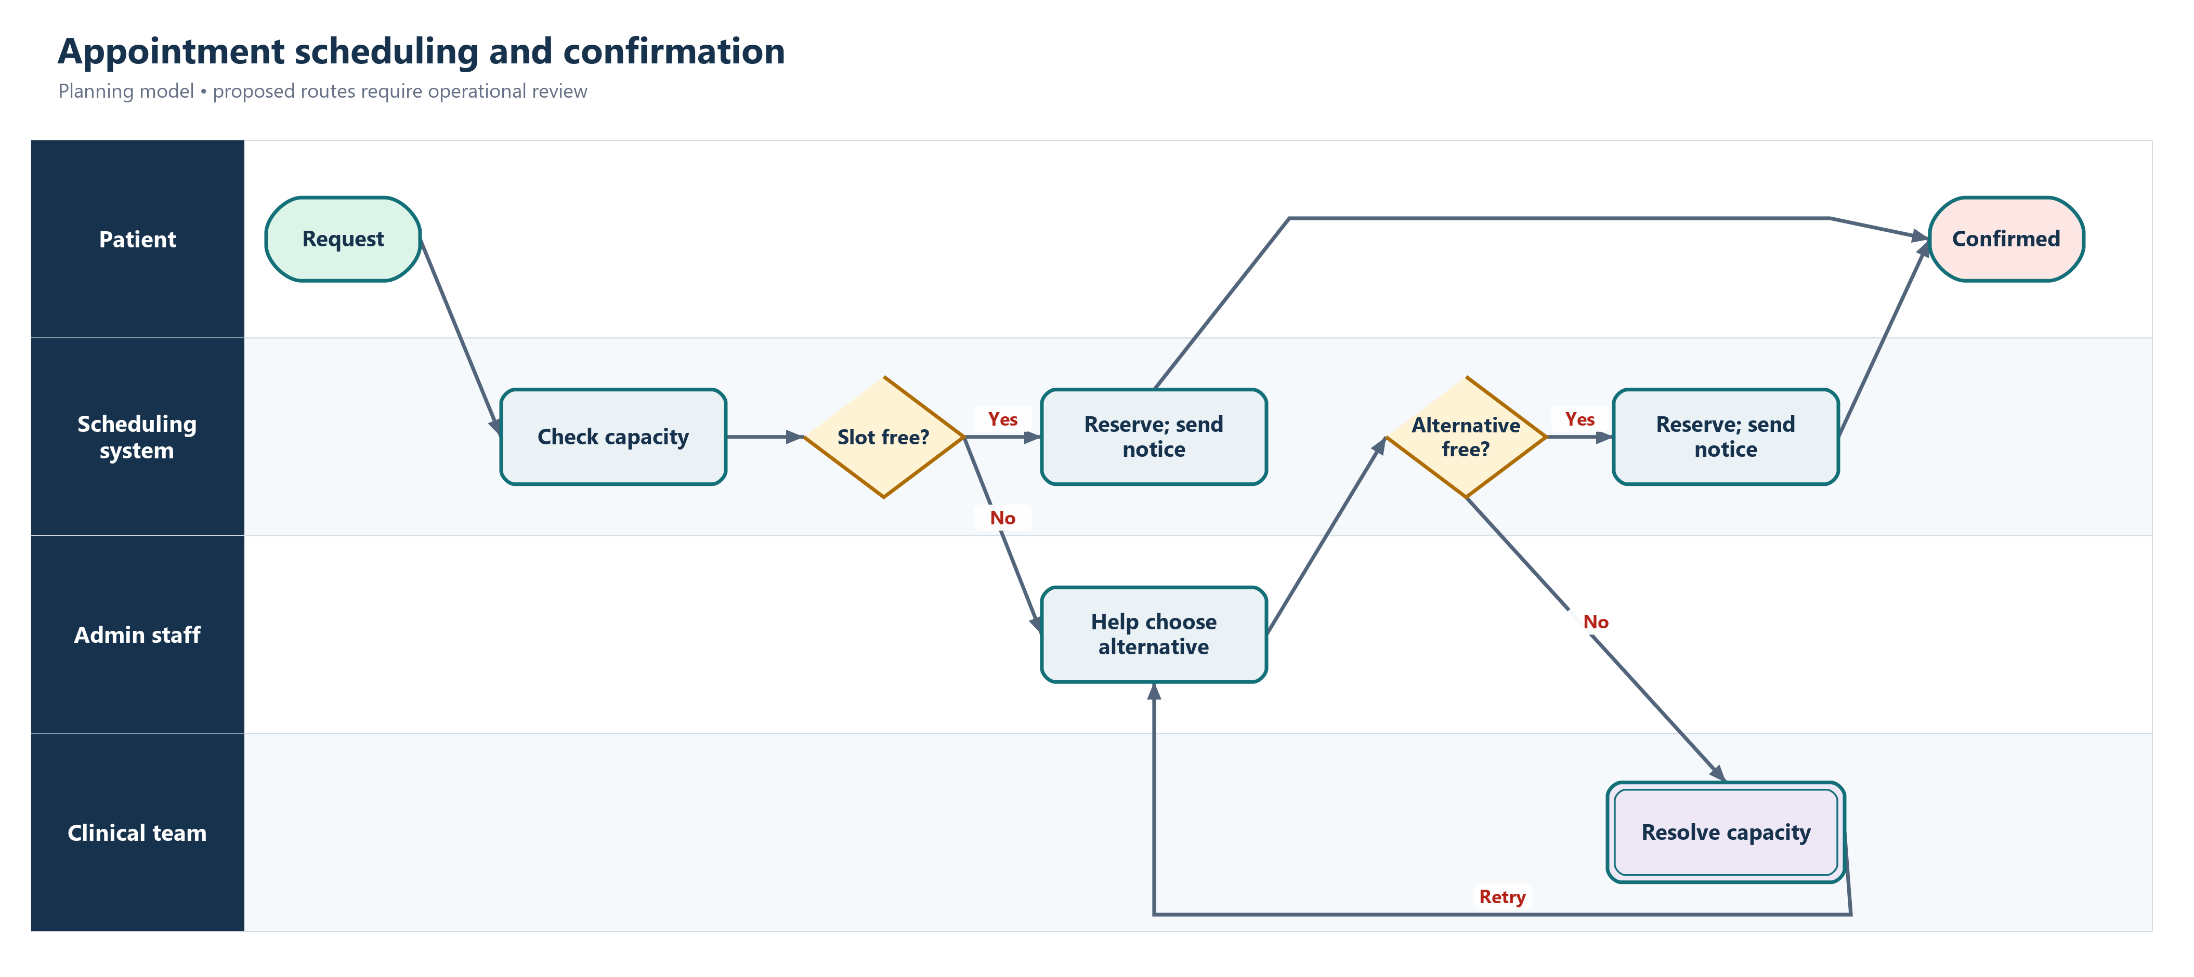
Appointment scheduling and confirmation
- The scheduling system owns conflict detection and reservation.
- Administrative staff own assisted-channel and delivery exceptions.
- Clinical teams maintain capacity rather than manually approving every ordinary request.

Patient check in and resource allocation
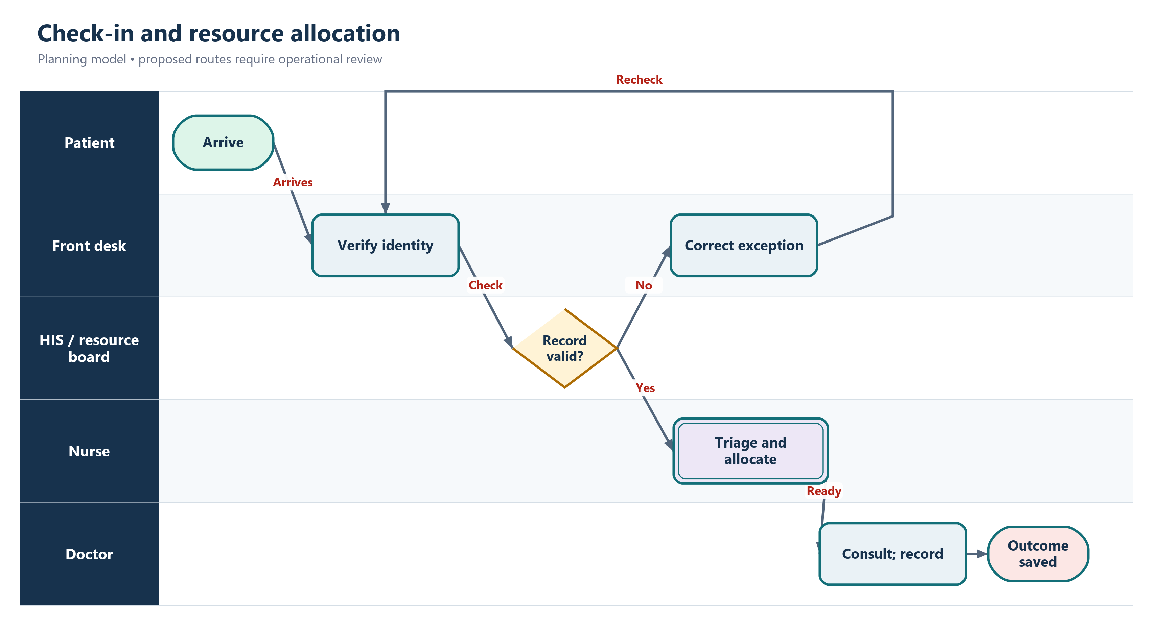
Patient check in and resource allocation
- Front-desk staff retain responsibility for identity and data exceptions.
- Nurses own triage and resource requests while the dashboard records availability.
- The consultation cannot be represented as complete until the clinical outcome is recorded.

Discharge planning
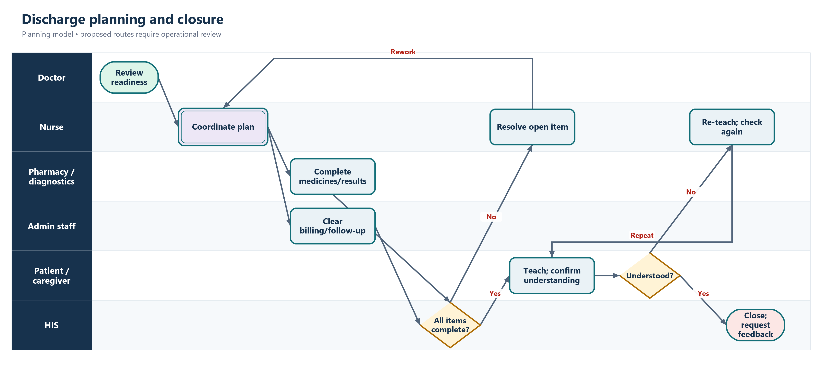
Discharge planning
- Discharge is a coordinated multi-workstream process, not a single clinical decision.
- The HIS blocks closure when a mandatory medicine, result, instruction, clearance or follow-up item remains open.
- Patient understanding is an explicit check with a teaching-repeat path.

