HealthFirst Care As Is and To Be Process Models
Capstone Project M03L01
Adwoa Boama Acheampong | IBM Business Analyst learning project

Analysis basis
The current-state models use the supplied profiles and the operational-data patterns. The future-state models are proposals. They have not been implemented or approved. Each model shows the main path and the control point most likely to prevent the documented failure.
Process | Current-state control gap | Proposed control and trace
Appointment scheduling | Manual availability checks and weak conflict/notice evidence | Validate capacity before reservation; offer an assisted alternative; FR-01–FR-05
Patient check in | Repeated paperwork and unresolved record exceptions | Validate identity and appointment; queue exceptions to staff; FR-05–FR-07
Interdepartmental handoff | Phone/email handoffs lack owner, status and acceptance evidence | Log request, assign owner, escalate and verify closure; FR-09–FR-10
Read each pair as a planning hypothesis. The As-Is model records the stakeholder-described weakness; the To-Be model makes the proposed decision point, exception and rework path visible. Operational owners must validate the paths before they become a process baseline.

Appointment scheduling
Current challenge. Manual booking, limited live availability, double-booking risk and late notices.
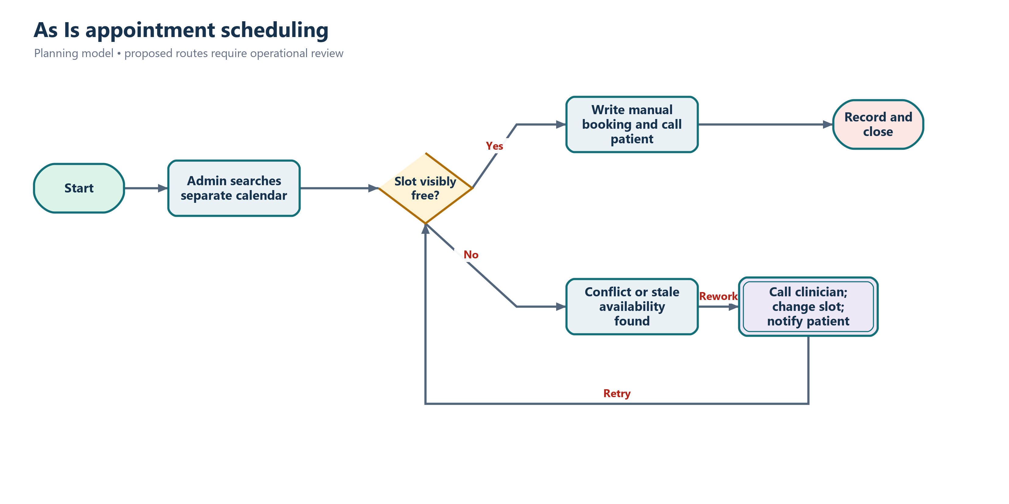
Current state
Proposed response. Validate fields and capacity before reservation, offer alternatives and retain notice-delivery evidence.
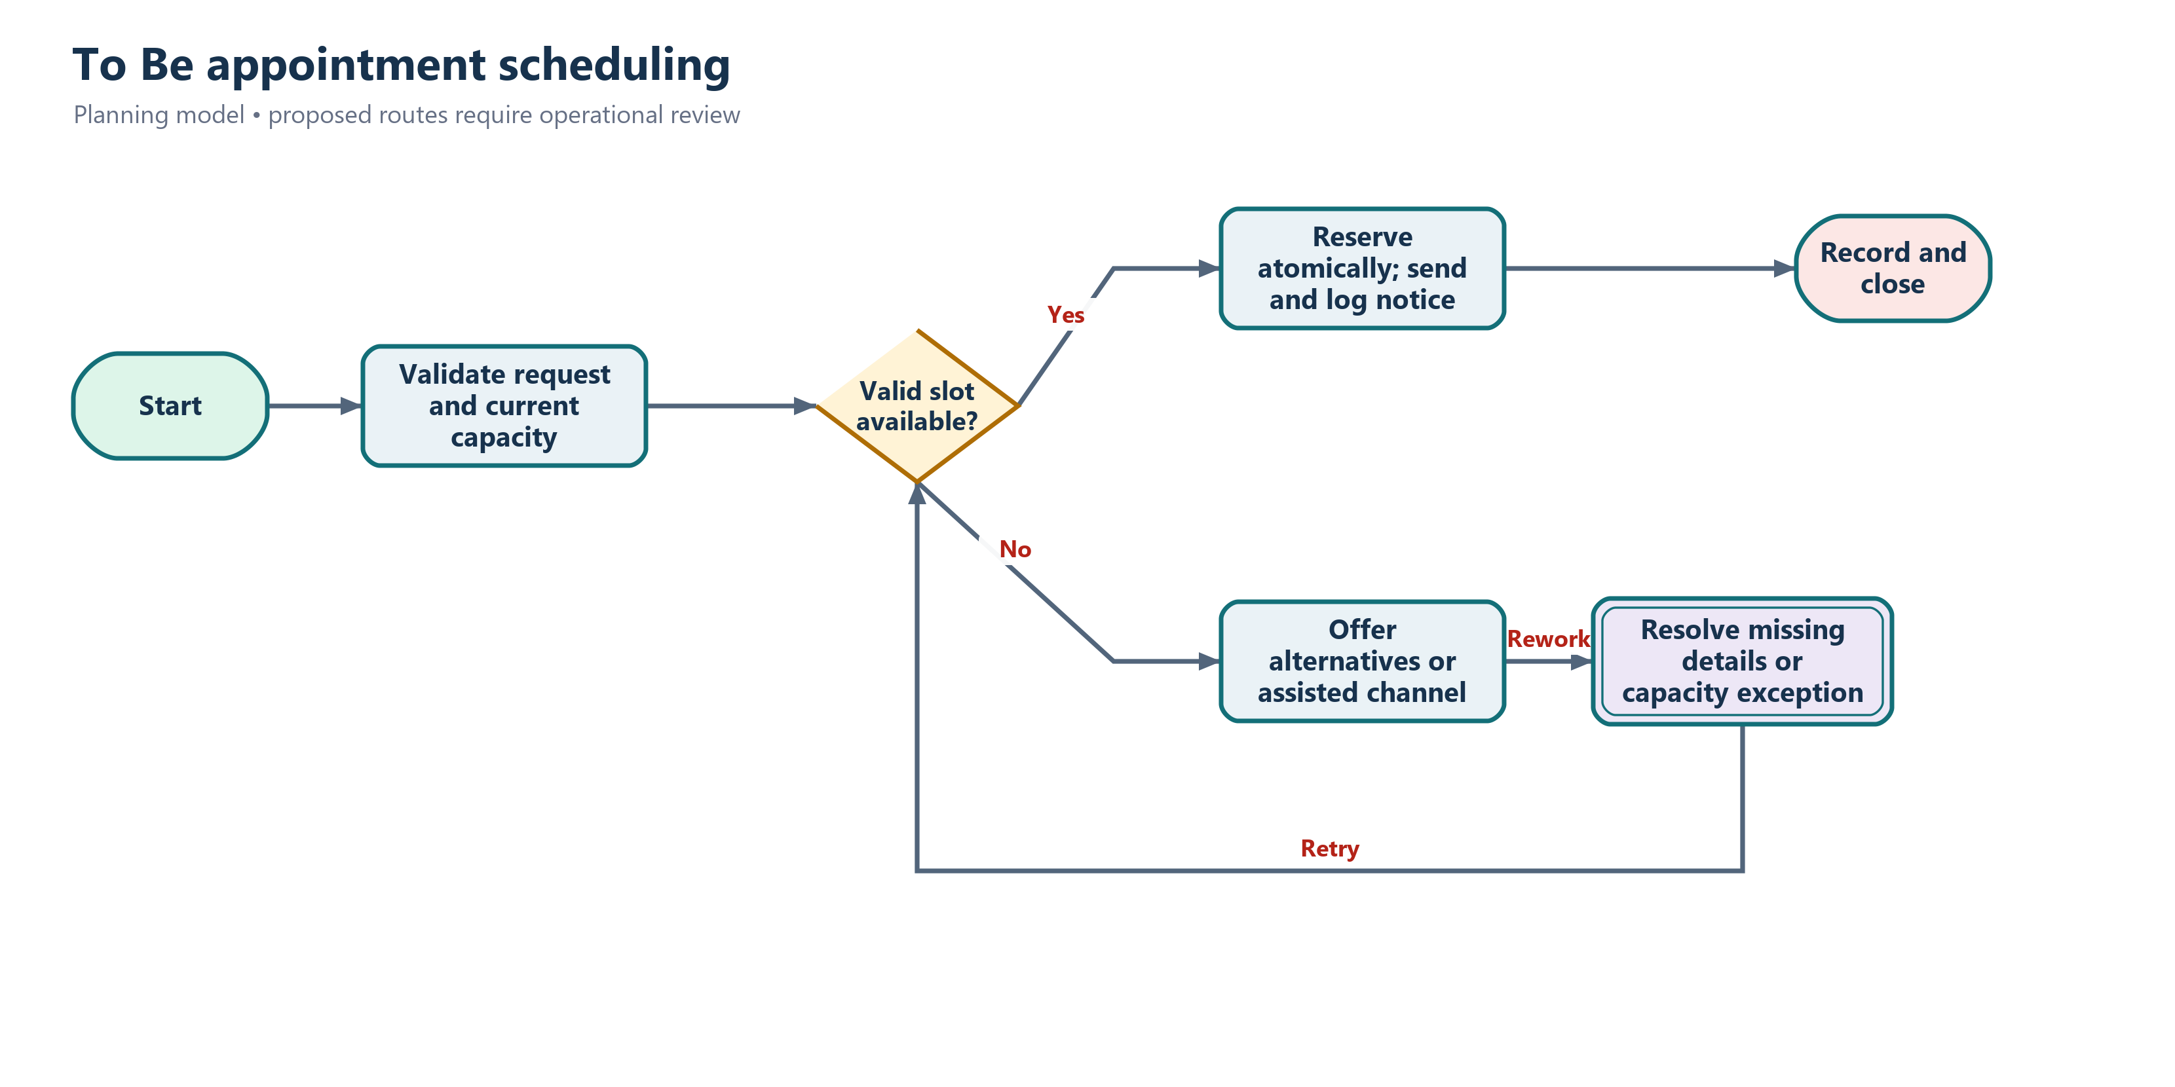
Proposed future state
Traceability | Measure | Exception
FR-01 to FR-05 | Track cycle time, unresolved exceptions and completion using sponsor-approved thresholds. | Route failed validation, unavailable capacity, inaccessible channel or unowned issue to the accountable operational role.

Patient check in
Current challenge. Repeated paperwork, slow record retrieval and unclear exception handling extend the queue.
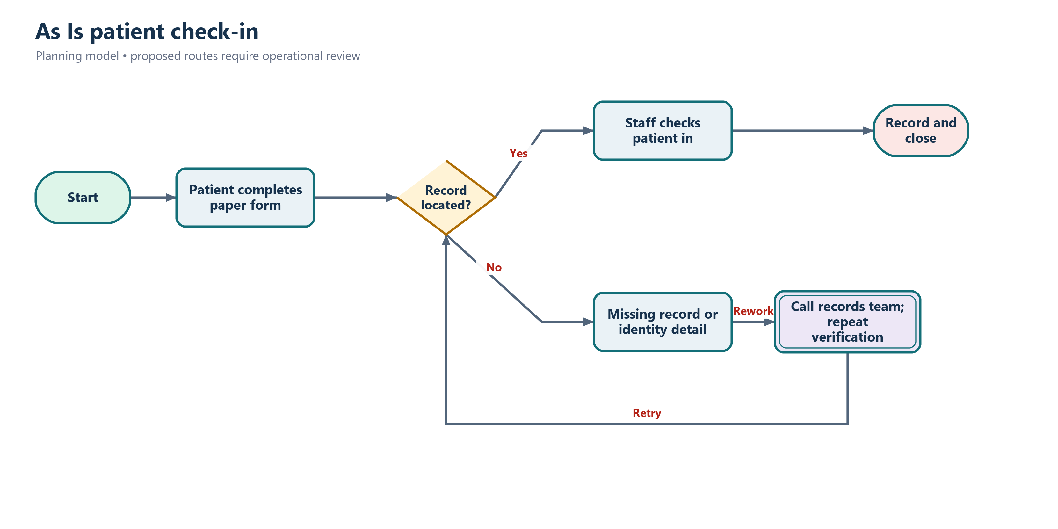
Current state
Proposed response. Allow pre-check-in or kiosk use while retaining staff support and a visible exception route.
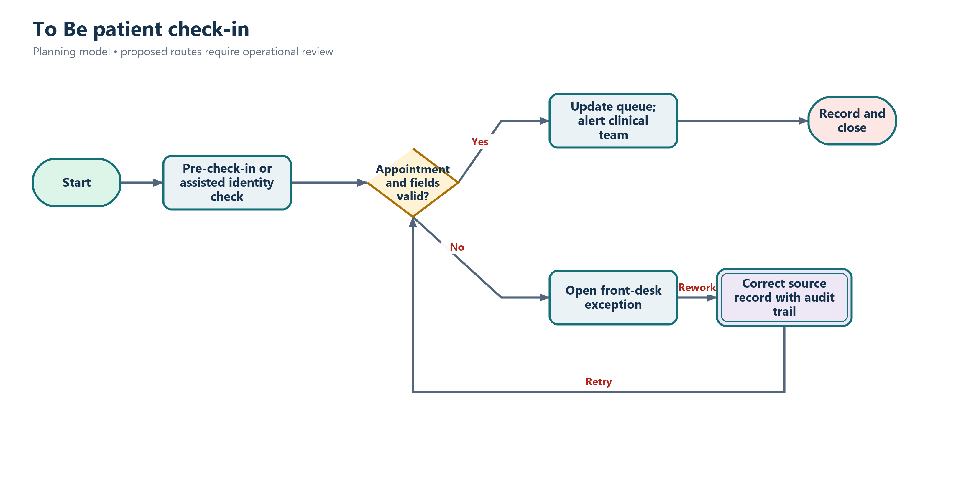
Proposed future state
Traceability | Measure | Exception
FR-05 to FR-07 | Track cycle time, unresolved exceptions and completion using sponsor-approved thresholds. | Route failed validation, unavailable capacity, inaccessible channel or unowned issue to the accountable operational role.

Interdepartmental communication
Current challenge. Phone and email handoffs lack a common queue, owner, priority and verification step.
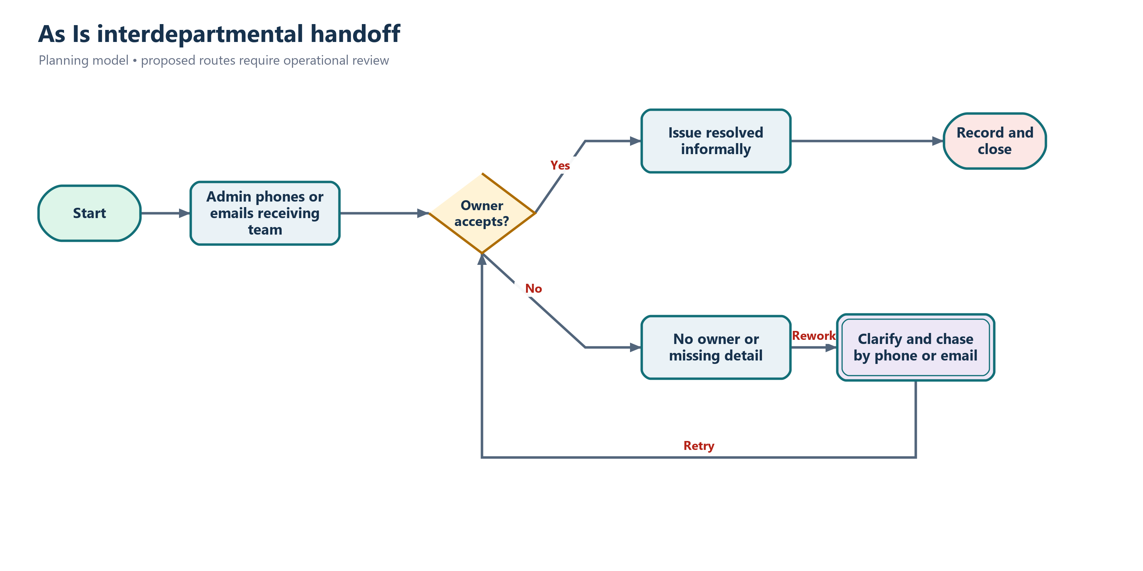
Current state
Proposed response. Use a structured request, assignment, escalation and requester verification before closure.
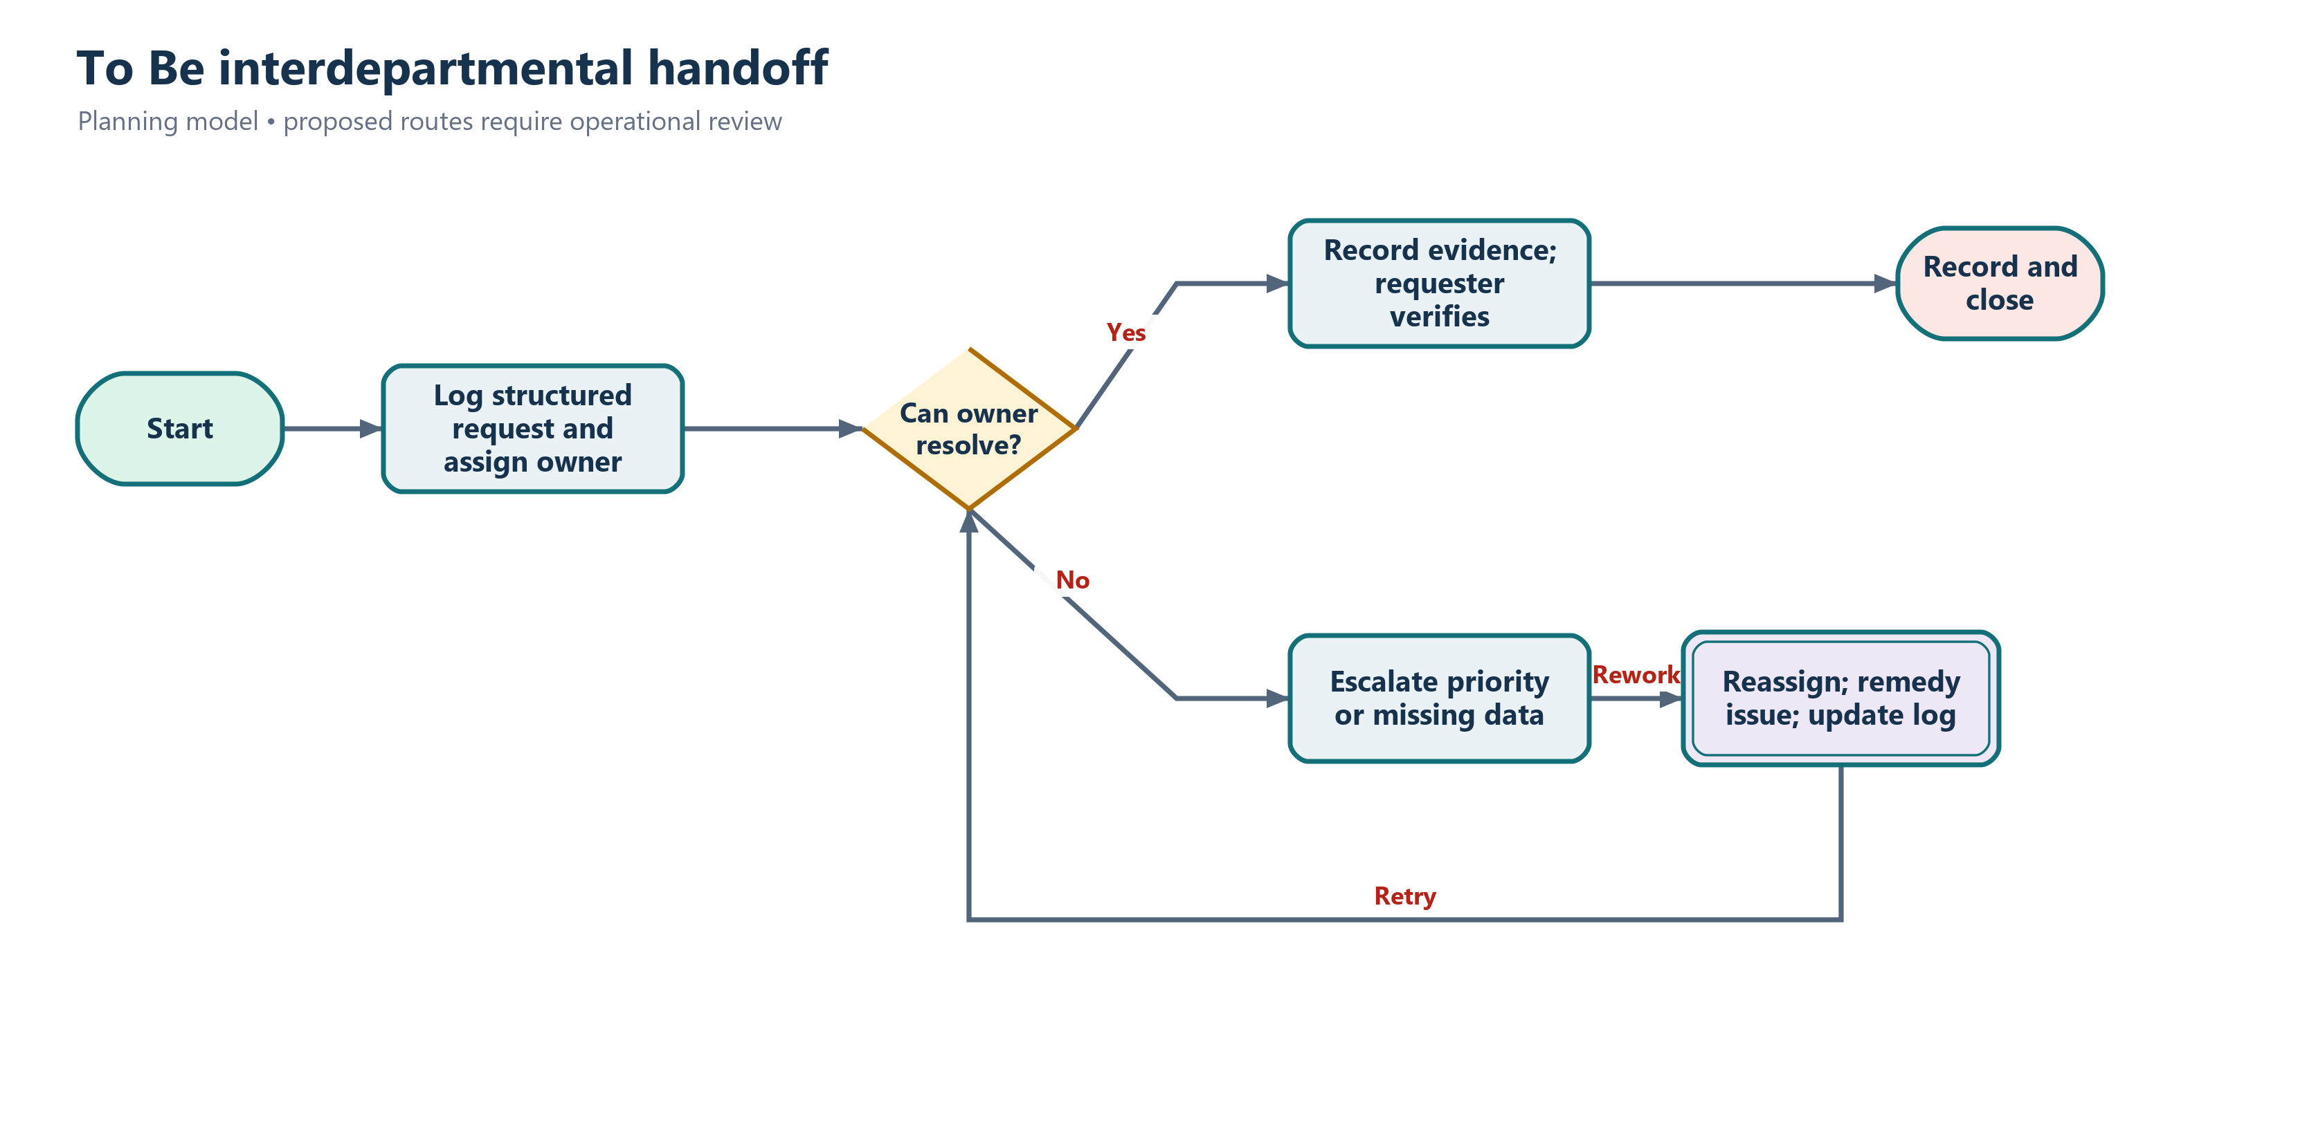
Proposed future state
Traceability | Measure | Exception
FR-09 and FR-10 | Track cycle time, unresolved exceptions and completion using sponsor-approved thresholds. | Route failed validation, unavailable capacity, inaccessible channel or unowned issue to the accountable operational role.

Cross-process findings
- The main control gap is not the number of steps; it is the absence of validated shared state at handoffs.
- Automation must expose exceptions rather than convert missing information into a plausible zero or completed status.
- Assisted patient channels and downtime processes remain part of the future state.
- Department-level data supports prioritization but does not establish individual patient-level causation.

