HealthFirst Care Scope Management Plan and Work Breakdown Structure
Capstone Project M02L02
Adwoa Boama Acheampong | IBM Business Analyst learning project

Scope statement
The project will define and validate a controlled operational pilot for appointment scheduling, patient communication, check-in, handoffs, resource visibility and reporting. The intended outcome is evidence for a scale, revise, pause or rollback decision. The work does not include clinical decision automation or full hospital-platform replacement.

Objectives inclusions and exclusions
Area | Definition | Acceptance evidence
Objectives | Reduce scheduling conflict and delay, improve communication and make operational status traceable | Sponsor-approved measures and UAT evidence
Inclusions | Requirements, stakeholder engagement, process models, data analysis, dashboard, risk controls, pilot preparation | Artifacts mapped in the project index
Exclusions | Clinical decisions, major construction, permanent staffing, full billing/lab/EMR replacement | Change log confirms no unapproved expansion

Assumptions dependencies and constraints
Type | Item | Control
Assumption | Operational owners are available for design and validation | Record review attendance and unresolved decisions
Assumption | Source extracts can be refreshed during a pilot | Define owner, frequency and freshness warning
Dependency | Legacy scheduling, patient-record and notification interfaces | Complete mapping and reconciliation before release
Constraint | Privacy, accessibility and clinical continuity remain mandatory | Treat as release gates
Constraint | No approved budget, dates or staffing plan were supplied | Use sequence and role ownership without invented commitments

Deliverables and acceptance
Deliverable | Acceptance criterion | Responsible reviewer
BRD and RTM | Requirements trace to source, objective, planned validation and open status | Sponsor, business analyst and owners
Stakeholder plan | All supplied profiles represented and engagement routes defined | Project sponsor and functional leads
Process models | As-Is and To-Be flows show decisions, exceptions and ownership | Operational and clinical leads
Analytical workbook and dashboard | Controls reconcile, pivots refresh and missing data are visible | Data owner and operations
Risk and mitigation plans | High risks have owner, trigger, prevention, contingency and review cadence | Risk owners and sponsor

Hierarchical WBS
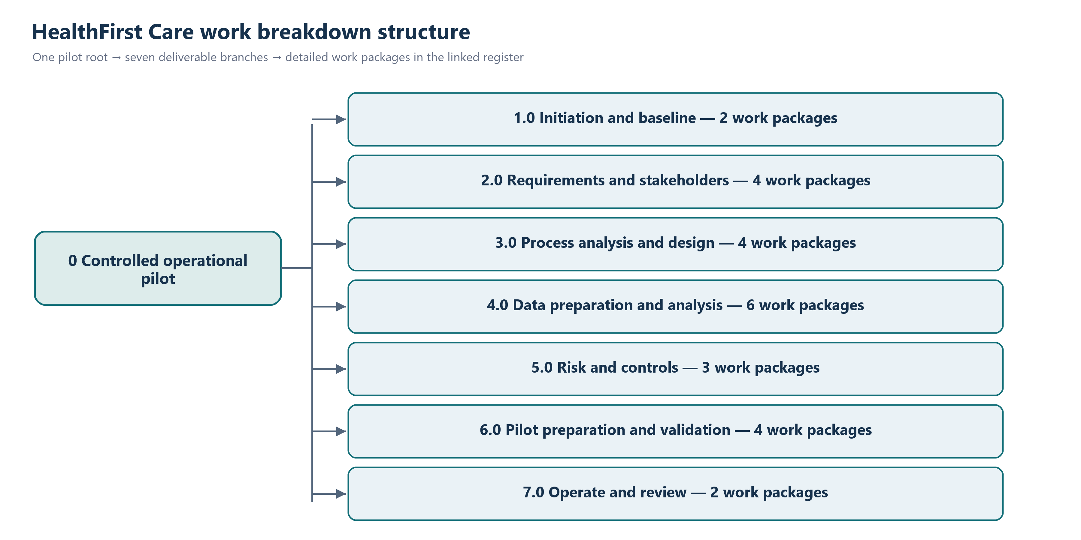
The pilot root decomposes into seven deliverable branches. The full work-package register follows; each branch also has its own editable diagram.
The seven detailed branch diagrams are supplied in HealthFirst_Editable_Diagrams as wbs_branch_1.svg through wbs_branch_7.svg, with matching PNG previews. Each branch expands its phase into work packages and review milestones.
WBS | Work package | Owner | Dependency | Milestone or output
1.0 | Initiation and baseline | Project sponsor | — | Project charter and decision rights
1.1 | Confirm problem statement and intended outcomes | Business analyst | 1.0 | Problem statement reviewed
1.2 | Confirm governance, roles and decision routes | Project manager | 1.0 | Governance baseline
2.0 | Requirements and stakeholders | Business analyst | 1.0 | Requirements baseline
2.1 | Review profiles and operational datasets | Business analyst | 1.1 | Evidence inventory
2.2 | Document BRD and open questions | Business analyst | 2.1 | BRD review
2.3 | Build and reconcile RTM | Business analyst | 2.2 | RTM review
2.4 | Complete stakeholder analysis and engagement plan | Business analyst | 2.1 | Engagement plan review
3.0 | Process analysis and design | Business analyst | 2.0 | Workflow design baseline
3.1 | Model appointment As-Is and To-Be | Business analyst; scheduling | 2.3 | Workflow review
3.2 | Model check-in As-Is and To-Be | Business analyst; front desk | 2.3 | Workflow review
3.3 | Model interdepartmental communication | Business analyst; IT | 2.3 | Workflow review
3.4 | Build appointment, check-in and discharge swimlanes | Business analyst; clinical leads | 3.1–3.3 | Role/handoff review
4.0 | Data preparation and analysis | Data analyst | 2.1 | Analysis baseline
4.1 | Preserve and profile raw sources | Data analyst | 2.1 | Source control totals
4.2 | Clean duplicates, dates, missing values and categories | Data analyst | 4.1 | Clean datasets
4.3 | Validate keys, joins, cardinality and unmatched rows | Data analyst | 4.2 | Quality log
4.4 | Build patient feedback summary and appointment lookup | Data analyst | 4.3 | Combined analysis
4.5 | Create native PivotTables, charts and slicers | Data analyst | 4.4 | Analytical workbook
4.6 | Build and validate dashboard | Data analyst; operations | 4.5 | Dashboard review
5.0 | Risk and controls | Business analyst; risk owners | 2.0–4.0 | Risk baseline
5.1 | Create risk register and SWOT | Business analyst | 3.0;4.0 | Risk review
5.2 | Prioritize risks and define mitigation | Risk owners | 5.1 | Mitigation review
5.3 | Define contingencies, triggers and monitoring | Risk owners | 5.2 | Continuity review
6.0 | Pilot preparation and validation | Project team | 3.0–5.0 | Go/no-go evidence
6.1 | Configure pilot workflows and controls | IT; operations | 3.0;5.0 | Pilot ready
6.2 | Prepare role-based training and support | Change lead | 6.1 | Training ready
6.3 | Execute planned UAT and reconcile RTM | UAT lead; stakeholders | 6.1 | UAT decision
6.4 | Review security, downtime and data-quality gates | IT; security; data owner | 6.1 | Control decision
7.0 | Operate and review | Operations; sponsor | 6.0 | Pilot review
7.1 | Monitor agreed KPIs, adoption, exceptions and risks | Operations; data owner | 6.3 | 30-day review
7.2 | Decide scale, revise, pause or rollback | Sponsor; governance group | 7.1 | Decision recorded
Open the standalone, editable WBS register

Scope validation and change control
- Submit a change request with rationale, affected requirements and requested timing.
- Assess impact on objective, data, workflow, security, continuity, dependency, effort and risk.
- Business analyst recommends approve, reject or defer. Sponsor or delegated governance group decides.
- If approved, update the BRD, RTM, WBS, risk register, acceptance evidence and communication plan.
- Emergency patient-safety or security changes use expedited governance and receive retrospective review.

Monitoring
The project manager tracks WBS outputs and unresolved decisions. The business analyst reconciles scope against the BRD and RTM at each gate. A deliverable is accepted only when the named reviewer records a decision; draft completion is not approval.

